Expense Report Data Entry – Key Field Standards
Six key fields in Concur assist employees and approvers in defining whether an expense is a reasonable and appropriate business expense. The chart below details what data is required, and where departments may desire to incorporate additional data for reporting and reconciliation needs.Note: The | (pipe), ; (semi-colon), or “ (quote) symbols should not be utilized in any Concur free-form fields, as they may cause upload errors when Concur data is imported into M-Pathways.
D
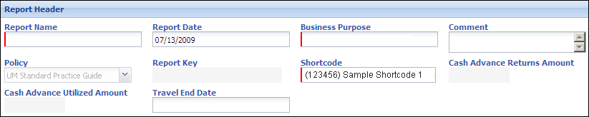  C  B  A | 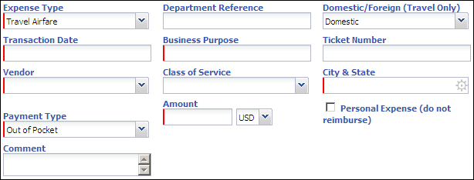  F  E

 | Field Name | Field Length (Char.) | Imported into M-Pathways | University Notes/Recommendations | Unit Notes/Recommendations
A | (Header) Report Name | 30 | First 20 characters combine with numeric Concur Report ID to populate the M-Pathways voucher Invoice ID field  Invoice ID field appears on the Voucher Detail Expense Report | The Report Name should include a keyword/description that identifies the primary reason for the expense. Examples:  - Travel, Hosting, Recruitment, Conference, P-Card Expenses, or Reimbursement  Note: Trips booked in Concur Travel will populate Report Names such as Trip Detroit to St. Louis, and this is acceptable.
B | (Header) Business Purpose | 64 | No | Business Purpose should provide detail complementing the Report Name entered. Examples:  - HEUG Board Meeting, Departmental Meeting Expenses, Professor Smith Recruitment, HEUG Conference 2009, September P-Card Expenses, or Copy Costs for Biology Presentation  Notes:  The Trip Purpose from a reservation booked in Concur Travel defaults to this field.  The (Header) Business Purposes defaults to the (Line) Business Purposes in the report.
 | Field Name | Field Length (Char.) | Imported into M-Pathways | University Notes/Recommendations | Unit Notes/Recommendations
C | (Header)  Comment | 500 | No | (Header) Comment is an optional field that you can populate to provide additional information about the expense report for approvers.
D | (Line) Department Reference | 48 | Populates the Department Ref # field on the M-Pathways voucher  Dept Ref # field appears on the Voucher Detail Expense Report | Department Reference is designed for you to further identify the expense. It can be used in any way departments see fit.  (Optional) Departments may use this field to enter a departmentally-generated description that can be used to tie expense reports from multiple employees together for reporting purposes or to track expenses related to an event that occur over time for an employee.
E | (Line) Business Purpose | 64 | First 30 characters from the (Line) Business Purpose field populates the M-Pathways Voucher Line Description field  Voucher Line Description field appears on the Voucher Detail Expense Report | The (Line) Business Purpose should explain why the specific expense is necessary to the U-M.  If an expense is incurred on behalf of another employee or U-M guest, indicate that individual’s name (e.g. Dr. Smith - Medical License Renewal).  Business Lunch, Conference, or Trip are not acceptable values as they are too generic and do not indicate the benefit to the U-M. Acceptable options include:  - Professor Jones - Recruiting Lunch or HEUG Conference 2009  Notes:  The (Line) Business Purpose defaults from the report header. Often this is appropriate (e.g. all expenses apply to the same trip), but you may need to modify the line value to provide a more specific explanation.
F | (Line) Comment | 500 | No | (Line) Comment allows employees to include additional information about the expense.  A Comment is required for any “yellow flag exception” employees receive indicating they have exceeded U-M spending thresholds for this expense type. The comment provides justification for approver(s).

