Online Gap Analysis Tool Step-by-Step

Overview
The Internal Controls certification process requires that units complete a gap analysis for applicable finance-related processes for their departments on an annual basis to ensure proper controls are in place or identify corrective action plans to address control gaps. The M-Reports Online Gap Analysis tool provides units with the ability to complete their responses for each department within the unit and for management to review the results.

Navigation
Log into Wolverine Access (http://wolverineaccess.umich.edu) > Faculty & Staff > Reporting > M-Reports.
M-Reports Landing Page
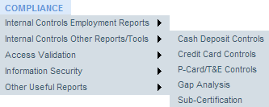  1  2  3 |  | - Hover over the COMPLIANCE tab.  - Hover over Internal Controls Other Reports/Tools.  - Click Gap Analysis.  The Gap Analysis Summary by Process page shows a list of departments and completion status indicators for each of the major processes.
Gap Analysis by Department - Summary by Process Page
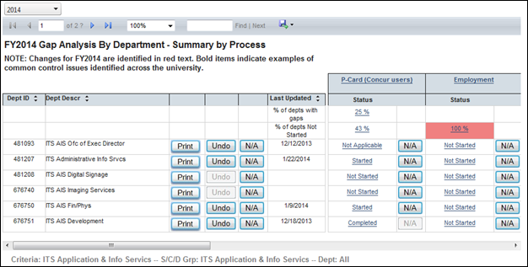  7  10  8  9  5  4 |  | - To change the fiscal year, use the pull down menu.  - To mark all the questions of all processes Not Applicable for a department, click the N/A button to the right of the department ID. To undo that action, click Undo.  - Enter the rationale for the N/A response in the Reason box and click OK (not shown).  - To view additional processes, use the horizontal scroll bar.  - To view a list of the departments with a status of Not Started or with identified gaps for a process, click the appropriate percentage link.  - To access the gap analysis tool for a specific process and department, click Not Started, Started, or Completed in the appropriate row and column. If a process is not applicable to the department, click N/A.  - Click any linked process to view the same information by sub-process.
Gap Analysis by Department Process Page
15
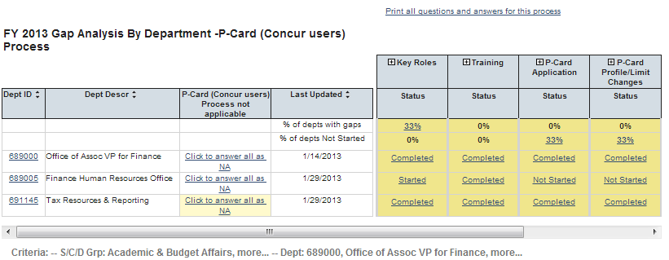  13  14  12  11 |  | - To access the first question in the first process for a department, click the linked Dept ID.  - To indicate all the questions in a process are not applicable to a department, click the appropriate Click to answer all as NA link in the Process not applicable column.  Note: This is the same action as using N/A for a department on the Gap Analysis Summary by Process page. See Step 8.  - To go to the first question in a sub-process for a department, click the appropriate Completed, Started, or Not Started link in the appropriate sub-process column.  - To view information for all the questions within a sub-process, click the plus sign next to a sub-process. Click the minus sign to collapse the sub-process.  - Click the Print all questions and answers for this process to go to a table view of the responses for the process.
Gap Analysis by Department Process Page (Printable View)
17
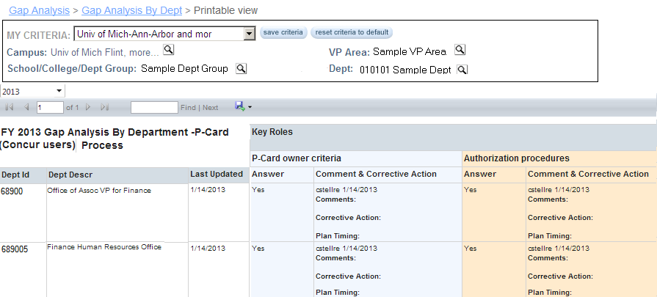  16 |  | - If appropriate, export this information. Click on the Export icon and select an option, such as Excel.  - Use the bread crumbs or appropriate links to move to the Questionnaire page.

Questionnaire Page
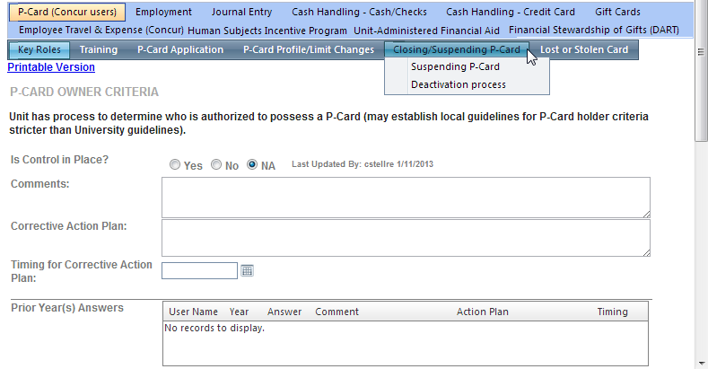  18  22  23  20  21  19  24 |  | - To move to a specific sub-process, click on it. To move to a specific question, hover over the sub-process. Click on the appropriate question in the resulting list.  - Click the appropriate response to the question.  Note: Italicized text within a question indicates a change for the current fiscal year. If the question/control is new for the current fiscal year, the question will include the text NEW CONTROL.  - If appropriate, review the prior year’s answers.  - If applicable, type information in Comments box and/or the Corrective Action area.  Note: Comments are required for a No response.  - If appropriate, use the Timing for Corrective Action calendar to specify a completion date for the corrective action plan.  - Use the vertical scroll bar to move down through the questions in the sub-process.  - When you have responded to the last question, click Next (Save) to move to the questions for the next sub-process. If you need to go back to the previous sub-process, click Prev (Save).  Note: Answers are ONLY saved when Save has been clicked. If you are logged out due to a timeout or if you click on another button or tab, you will leave without saving your responses.

Related Resources
- Office of Internal Controls Web site: http://www.finance.umich.edu/controls

Additional Assistance
Questions, feedback, and requests for enhancements can be submitted to the Information and Technology Services (ITS) Help Desk:
- Phone: 734-764-HELP (4357)
- Web: http://www.its.umich.edu/help

