Make a Human Subject Incentive Payment (HSIP) Request Template
This step-by-step procedure demonstrates how to make a HSIP request template in M-Pathways. A requester who will be making multiple requests for a study may want to make a template to save time on future requests.
For more information on the business process surrounding approving an HSIP request, please refer to the training resources on the Treasurer’s Office Web site: http://www.treasury.umich.edu/hsiptrainingresources.htm.

Navigation
University Business >Treasury Management > Human Subject Incentive Payment Request
M-Pathways Home Page
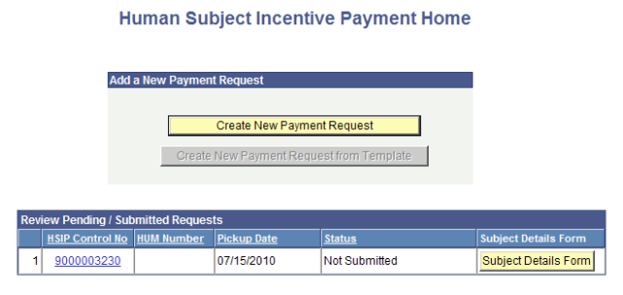  1 |  | - Go to home page by logging into Wolverine Access and click on the HSIP Control No. for the request that you wish to make a template of. You cannot make a template until you have Saved or Saved and Submitted a request.  NOTE: Templates are at the study level. You do not need to make a template for each type of payment. This information does not save in the template.
HSIP Form Page
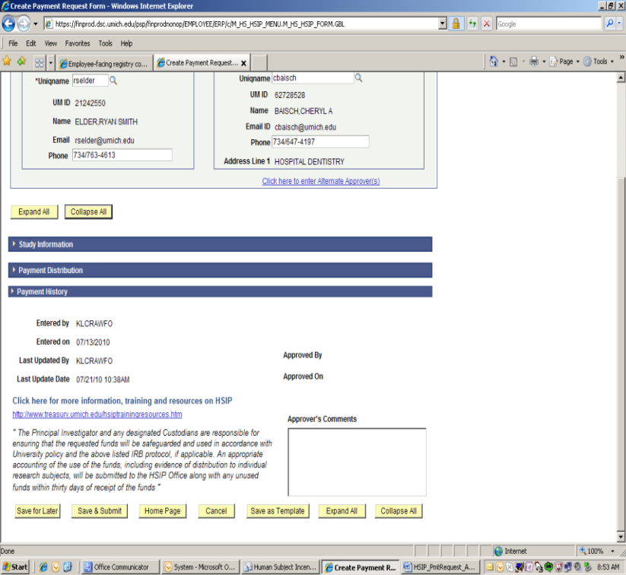  2 |  | - Scroll to bottom of form and locate the Save as Template button  NOTE: The following information saves in a template.  - PI Information  - Approver Information (Alternate Approvers do not save)  - Study Information  - Prime Custodian (Alternate Pick-ups do not save)  - Accounting Information  No payment details or delivery information save in the template since those may change with each request.
Name and Save Template 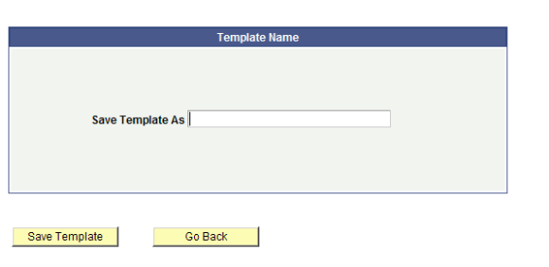  3  4 |  | - Type in Template Name.  - Click on Save Template  Notes:  - Name template something that you will remember – short study name is most commonly used.  - Click on Go Back if you do not want to proceed with saving a template
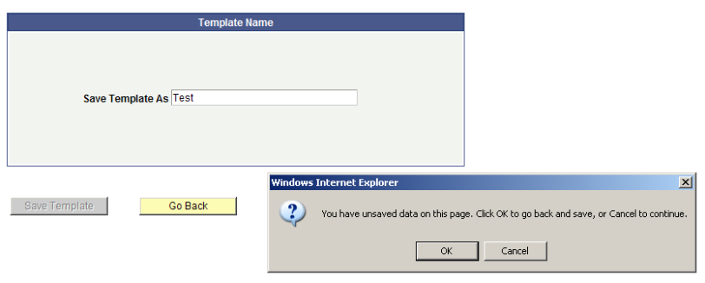  5 |  | - Unsaved date error will pop up. Click OK
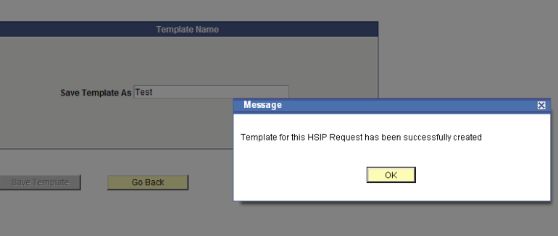  6  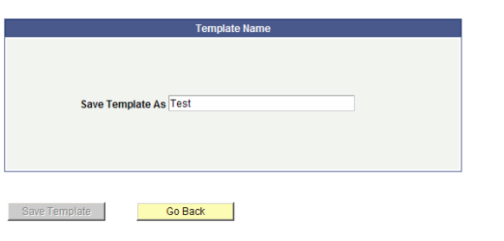  7 |  | - Template has been successfully created message pops up. Click OK.  9  - System goes back to Template Name page. Click Go Back.  9  Note: At this point your template has been saved so Go Back returns you to the form that you have saved a template from.  - On form click Home Page  - Unsaved information error will pop up, click Cancel.
Create Request From Template  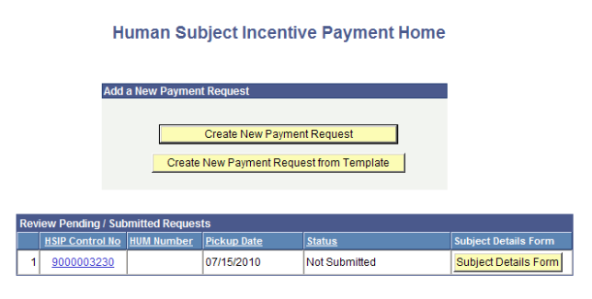  8 |  | 8. The home page now has a new button called Create New Payment Request from Template. To create a new request from a previously saved template, click this button.
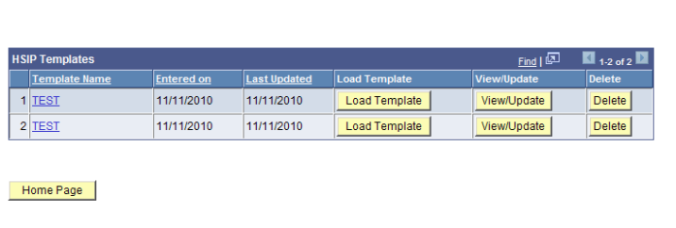  9 |  | 9. Click on Load Template to start a new request from your template.  NOTE: Templates do not update automatically when information changes. Any change in study information, (such as tier, approval dates etc.) require you to make a new template. Please press Delete to remove old template.  View/Update can be used to change Approver, Custodian or Accounting details. You cannot change study information in View/Update.

